Zebra’s Yellow Van
Name: __________________________________________
Directions: Where did Zebra’s van go? Cut and paste the words to complete the sentences.
Zebra’s 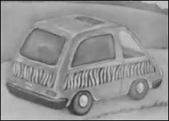was | 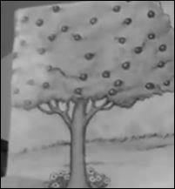
Zebra’s 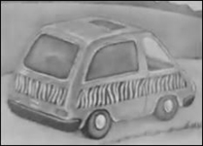was | 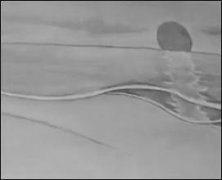
Zebra’s was | 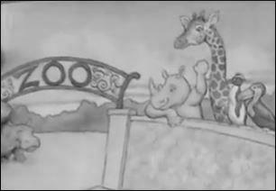
Yes, it was Zebra’s! | The End!
by the zoo. | by the tree.
by the sea.

http://www.topsthemonkey.com

