Name: __________________________________________
Directions: In the box draw something you can do. Write a sentence or two about it.

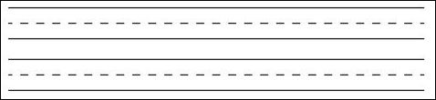
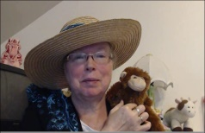http://www.topthemonkey.com

