Up They Go (Sequence)
Name: _____________________________________
Cut the pictures out. Paste them in the correct order.
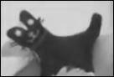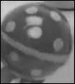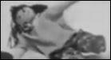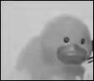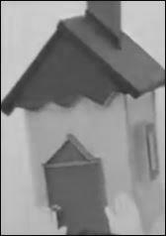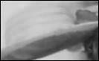
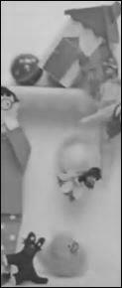

http://www.topsthemonkey.com

