Too High
Name: __________________________________________
Directions: Match the sentence with the picture to show the order of what happened in this story.
 | 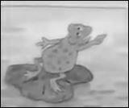
 | 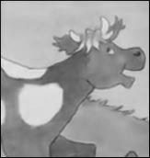
 | 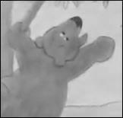
 | 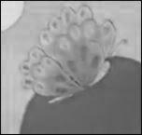
The cow said to get it. | The frog said to get the balloon.
The butterfly said it’s not too high for me. | The bear said I can’t get it.
http://www.topsthemonkey.com

