Three White Sheep
Name:_____________________________
In Box 1 draw a picture showing the problem in the story. In Box 2 draw a picture showing the solution.
Box 1

Box 2

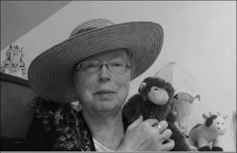http://www.topsthemonkey.com

