The Toy Box: (Using Basic Context Clues)
Name: ______________________________
Word Box: rabbit, clocks, blocks, bear
Complete the word in the blank.

- I see two bl_________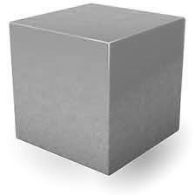 in the toy box.
- I see one b_________ 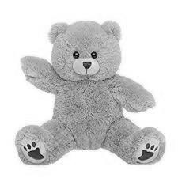 in the toy box.
- I see one r_________ 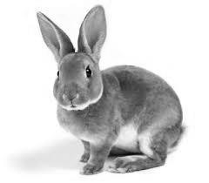in the toy box.
- I see two cl__________ 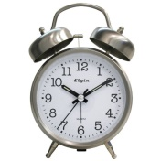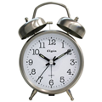in the toy box.

