Name: __________________________________________
Directions: What do you think will happen next? Draw and write what you think!

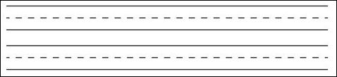
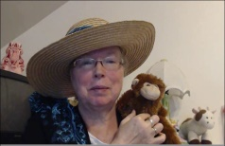http://www.topthemonkey.com

