Name: __________________________________________
Story Map for The Lion and the Mouse
Title: The Lion and the Mouse  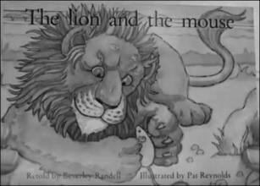 |  | Setting:
Main Character: | Problem: |  | Solution:
What Happens Next?

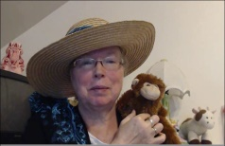http://www.topsthemonkey.com

