The Farm

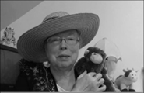Name: __________________________________

Cut and paste pictures in the box that belong on a farm.

|  |
| --- |
|  |

 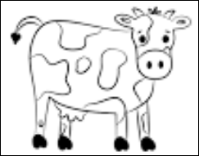 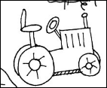 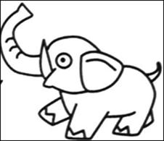

*http://www.topsthemonkey.com*