Name: __________________________________________
Story Map for Teasing Dad
Title: Teasing Dad  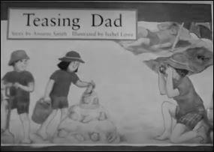 |  | Setting:
Main Character: | Problem: |  | Solution:
What Happens Next?

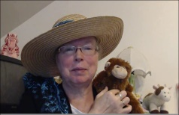http://www.topthemonkey.com

