Name: __________________________________________
Story Map for Milk
Title: Milk  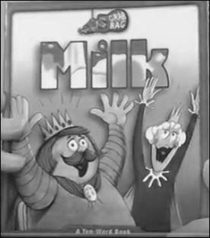 |  | Setting:
Main Character: | Problem: |  | Solution:
What Happens Next?

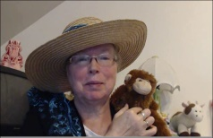http://www.topthemonkey.com

