Something New (cut-out pictures/sentences)

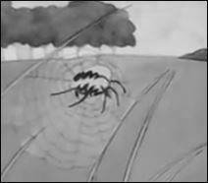 | 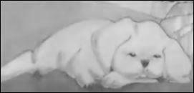
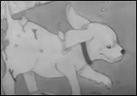 | 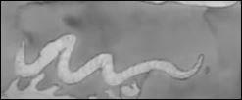

Spider wanted Pup to spin. | Pup wanted to dig.
Pup was tired of digging. | Worm wanted Pup to wiggle.

