 School Lunch

Name: _________________________________________

Cut and paste the pictures under the correct label.

|  |  |
| --- | --- |
| Food | Not a Food |
|  |  |
|  |  |
|  |  |

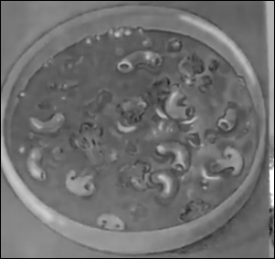 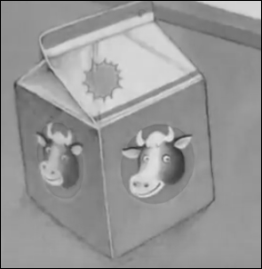 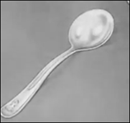 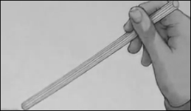

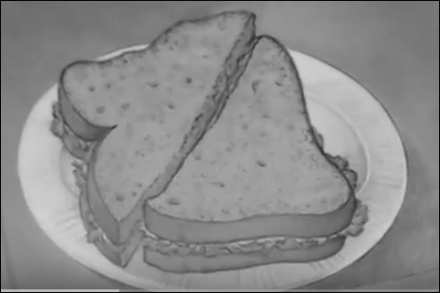 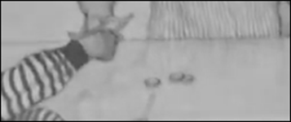

*http://www.topsthemonkey.com*