Name: __________________________________________
Directions: Draw and write about it? What is it? How do you know?

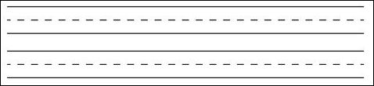
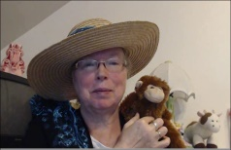http://www.topthemonkey.com

