Name: __________________________________________
Directions: In the box create your perfect pizza. Write a sentence or two about it.
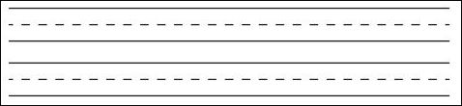
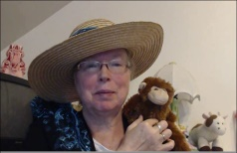http://www.topthemonkey.com

