Name: __________________________________________
Directions: Draw something that happened on the way to Grandma’s house? Write a sentence or two about it.

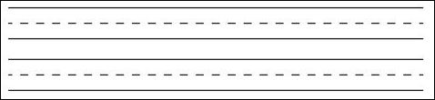
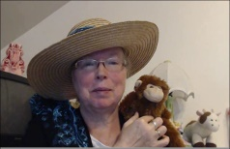http://www.topthemonkey.com

