Off to Grandma’s House (cut-out pictures/sentences)
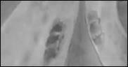 | 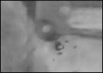
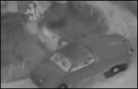 | 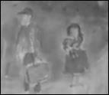
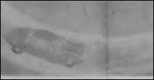

They went around a curve. | The family had a flat tire.
The family left for Grandma’s house. | The family arrived at Grandma’s house.
They were on the highway.
http://www.topsthemonkey.com

