The Nest

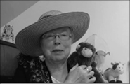Name: __________________________________

Cut and paste pictures in the box that are animal homes.

|  |
| --- |
| Animal Homes |

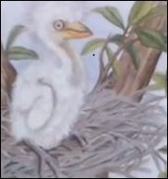 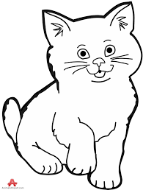 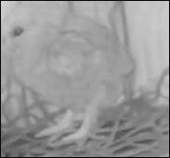 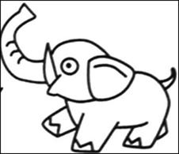 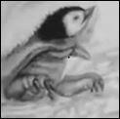

*http://www.topsthemonkey.com*