Name: __________________________________________
Story Map for Mrs. Spider’s Beautiful Web
Title: Mrs. Spider’s Beautiful Web  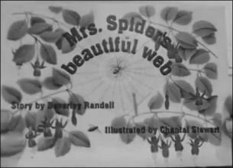 |  | Setting:
Main Character: | Problem: |  | Solution:
What Happens Next?

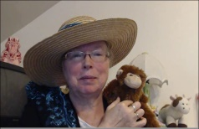http://www.topsthemonkey.com

