Mrs. Nichols and Tops the Monkey: A Book of Rimes for Second and Third Grade Students

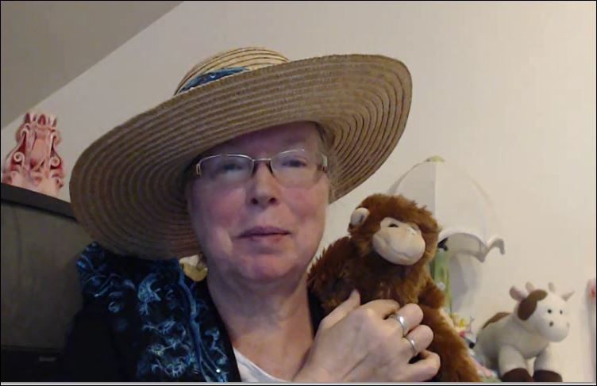

©original: TXu1-586-072

Rime: ‘at’

The cat sat on a hat.

It said,

It said, “Where

It said, “Where is that

It said, “Where is that rat?”

b-at, bat

m-at, mat

f-at, fat

p-at, fat

th-at, that

s-p-at, sp-at, spat

p-l-at, pl-at, plat

b-r-at, br-at, brat

The cat sat on a hat.

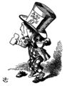

Rime: ‘ap’

A cap was on his lap.

Then he

Then he began

Then he began to

Then he began to rap.

m-ap, map

n-ap, nap

s-ap, sap

p-ap, pap

ch-ap, chap

s-l-ap, sl-ap, slap

f-l-ap, fl-ap, flap

t-r-ap, tr-ap, trap

A cap was on his lap.

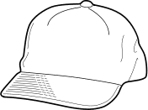

Rime: ‘an’

The man ran to a fan.

He said

He said it is

He said it is too

He said it is too hot.

b-an, ban

c-an, can

p-an, pan

t-an, tan

th-an, than

s-c-an, sc-an, scan

p-l-an, pl-an, plan

b-r-an, br-an, bran

The man ran to a fan.

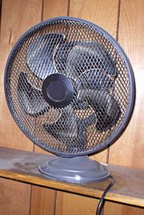

Rime: ‘in’

The fish had a pin on its fin.

“Get it

“Get it off,”

“Get it off,” said the

“Get it off,” said the fish.

b-in, bin

s-in, sin

t-in, tin

w-in, win

ch-in, chin

s-p-in, sp-in, spin

b-l-in, bl-in, blin

d-r-in, dr-in, drin

The fish had a pin on its fin.

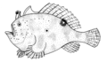

Rime: ‘ip’

She took a sip with one lip.

Then she

Then she shook

Then she shook her

Then she shook her hips.

d-ip, dip

n-ip, nip

r-ip, rip

t-ip, tip

sh-ip, ship

s-l-ip, sl-ip, slip

f-l-ip, fl-ip,flip

t-r-ip, tr-ip, trip

She took a sip with one lip.

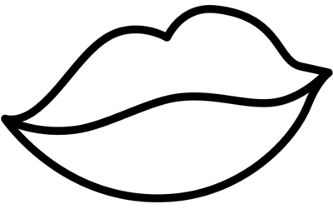

Rime: ‘op’

The rabbit will hop pass the mop.

There

There was

There was no time

There was no time to stop.

c-op, cop

p-op, pop

s-op, sop

h-op, hop

sh-op, shop

s-t-op, st-op, stop

f-l-op, fl-op, flop

c-r-op, cr-op, crop

The rabbit will hop pass the mop.

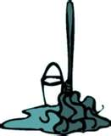

Rime: ‘ug’

The bug crawled on the rug.

It really

It really needs

It really needs a great

It really needs a great, big hug.

d-ug, dug

j-ug, jug

m-ug, mug

p-ug, pug

ch-ug, chug

s-l-ug, sl-ug, slug

p-l-ug, pl-ug, plug

t-r-ug. tr-ug, trug

The bug crawled on the rug.

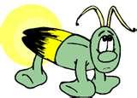

Rime: ‘ack,’ ‘ick’, ‘ock’, ‘uck.’

The duck with white socks was sick.

“Quack, quack,”

“Quack, quack,” said the sick

“Quack, quack,” said the sick duck wearing

“Quack, quack,” said the sick duck wearing white socks.

l-ack, lack

l-ick, lick

l-ock, lock

l-uck, luck

ch-uck, chuck

ch-ick, chick

s-l-ick, sl-ick, slick

s-l-ack, sl-ack, slack

t-r-ack, tr-ack, track

The duck with white socks was sick.

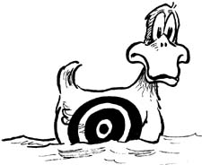

Rime: ‘all,’ ‘ell,’ ‘ill.’

On a tall hill a girl rang a bell.

“The bell

“The bell is too loud,”

“The bell is too loud,” everyone

“The bell is too loud,” everyone yelled.

w-ell, well

b-ell, bell

b-all, ball

b-ill, bill

ch-ill, chill

s-p-ill, sp-ill, spill

s-p-ell, sp-ell, spell

s-m-ell, sm-ell, smell

On a tall hill a girl rang a bell.

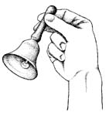

Rime: ‘ash’

The bears with a rash had a bash.

They

They like to

They like to gobble

They like to gobble mash potatoes.

c-ash, cash

h-ash, hash

l-ash, lash

s-ash, sash

sh-ash, shash

f-l-ash, fl-ash, flash

c-r-ash, cr-ash, crash

The bears with a rash had a bash.

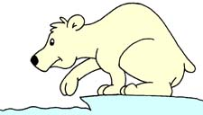

Rime: ‘ank,’ ‘ink,’ ‘unk.’

The cranky skunk began to stink.

“I do not care

“I do not care if I offend,”

“I do not care if I offend,” said the

“I do not care if I offend,” said the cranky skunk.

s-i-n-k, s-ink, sink

s-a-n-k. s-ank, sank

s-u-n-k, s-unk, sunk

ch-u-n-k, ch-unk, chunk

ch-I-n-k, ch-ink, chink

s-t-i-n-k, st-ink, stink

b-l-i-n-k, bl-ink, blink

d-r-i-n-k, dr-ink, drink

The cranky skunk began to stink.

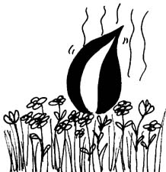

Rime: ‘est’

He took a test and did his best.

“I hope I

“I hope I did better

“I hope I did better than the rest,”

“I hope I did better than the rest,” the boy said.

b-e-s-t, b-est, best

j-e-s-t, j-est, jest

n-e-s-t, n-est, nest

r-e-s-t, r-est, rest

ch-e-s-t, ch-est, chest

s-n-e-s-t, sn-est, snest

p-l-e-s-t, pl-est, plest

c-r-e-s-t, cr-est, crest

He took a test and did his best.

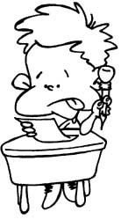

Rime: ‘ing’

The ring did not fit her fing-er.

She traded

She traded the ring for

She traded the ring for another

She traded the ring for another bling.

k-i-n-g, k-ing, king

s-i-n-g, s-ing, sing

w-i-n-g, w-ing, wing

b-i-n-g, b-ing, bing

ch-I-n-g, ch-ing, ching

s-w-i-n-g, sw-ing, swing

f-l-i-n-g, fl-ing, fling

b-r-i-n-g, br-ing, bring

The ring did not fit her fing-er.

..\..\..\..\Program Files\Microsoft Office\Clipart\standard\stddir2\BD07755_.WMF

Rime: ‘ump’

The frogs jumped in the dump.

They did

They did a dance

They did a dance called

They did a dance called the bump.

l-u-m-p, l-ump, lump

p-u-m-p, p-ump, pump

g-u-m-p, g-ump, gump

w-u-m-p, w-ump, wump

ch-u-m-p, ch-ump, chump

s-t-u-m-p, st-ump, stump

p-l-u-m-p, pl-ump, plump

c-r-u-m-p, cr-ump, crump

The frogs jumped in the dump.

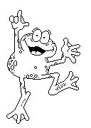

Rime: ‘ake,’ ‘ate.’

Jake dropped a plate of chocolate cake.

“Oh, no!”

“Oh, no!” said Jake.

“Oh, no!” said Jake. “Now, I’m going

“Oh, no!” said Jake. “Now, I’m going to be late.”

m-ake, make

m-ate, mate

r-ate, rate

r-ake, rake

sh-ake, shake

s-t-ake, st-ake, stake

f-l-ake, fl-ake,flake

b-r-ake, br-ake, brake

Jack dropped a plate of chocolate cake.

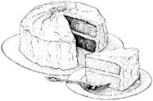

Rime: ‘ale,’ ‘ame’

Dale the whale did not like the name of the game.

It is called

It is called ‘pin the tale

It is called ‘pin the tale on the enormous

It is called ‘pin the tale on the enormous whale.’

s-t-ale, st-ale, stale

b-ale, bale

t-ale, tale

t-ame, tame

n-ame, name

sh-ame, shame

f-r-ame, fr-ame, frame

b-l-ame, bl-ame, blame

Dale the whale did not like the name of the game.

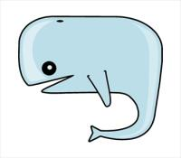

Rime: ‘ice,’ ‘ine.’

Nine mice sat on the ice to dine.

They made a straight line

They made a straight line until it was

They made a straight line until it was too cold on their

They made a straight line until it was too cold on their behind.

m-ine, mine

m-ice, mice

r-ice, rice

r-ine, rine

sh-ine, shine

s-p-ine, sp-ine, spine

s-p-ice, sp-ice, spice

s-l-ice, sl-ice, slice

p-r-ice, pr-ice, price

p-r-ine, pr-ine, prine

Nine mice sat on the ice to dine.

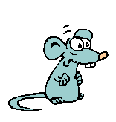

Rime: ‘ide,’ ‘ite,’ ‘ight’

The mice will ride the kite tonight in the moonlight.

The kite was too

The kite was too wide to fly

The kite was too wide to fly and that was the end

The kite was too wide to fly and that was the end of the ride.

r-ide, ride

r-ight, right

s-ight, sight

s-ide, side

ch-ide, chide

s-l-ide, sl-ide, slide

s-n-ide, sn-ide, snide

b-r-ide, br-ide, bride

b-r-ight, br-ight, bright

The mice will ride the kite tonight in the moonlight.

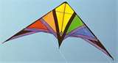

Rime: ‘oke,’ ‘ore’

Poke the Mule told a joke about a mole who lived under the store.

Since it was

Since it was boring Poke

Since it was boring Poke did not

Since it was boring Poke did not tell anymore.

t-ore, tore

m-ore, more

c-oke, coke

c-ore, core

ch-ore, chore

s-t-ore, st-ore, store

s-t-oke, st-oke, stoke

b-r-oke, br-oke, broke

Poke the Mule told a joke about a mole who lived under a store.

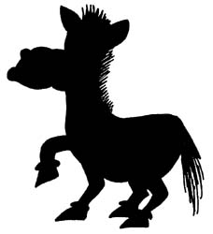

Rime: ‘ain’

He sprain his ankle running in the falling rain.

He caught

He caught a ride

He caught a ride on the speeding

He caught a ride on the speeding train.

r-ain, rain

p-ain, pain

g-ain, gain

m-ain, main

ch-ain, chain

s-t-ain, st-ain, stain

p-l-ain, pl-ain, plain

b-r-ain, br-ain, brain

He sprain his ankle running in the falling rain.

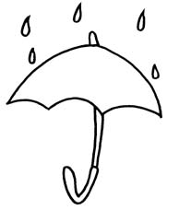

Rime: ‘eat’

It was time to eat a special treat.

Do you like

Do you like wheat

Do you like wheat toast with honey

Do you like wheat toast with honey and jam?

b-eat, beat

s-eat, seat

m-eat, meat

wh-eat, wheat

ch-eat, cheat

p-l-eat, pl-eat, pleat

t-r-eat, tr-eat, treat

It was time to eat a special treat.

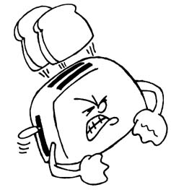

Rime: ‘or,’ ‘ir’, ‘ar,’ ‘ur.’

The star shined above the fir tree for all to see.

A giant saw it

A giant saw it and said,

A giant saw it and said, “for, fir, fur, far, that star is too far

A giant saw it and said, “for, fir, fur, far, that star is too far from me.”

f-ur, fur

f-or, for

f-ir, fir

f-ar, far

t-ar, tar

s-t-ar, st-ar, star

ch-ar-coal, char-coal, charcoal

th-ir-sty, thir-sty, thirsty

The star shined above the fir tree for all to see.

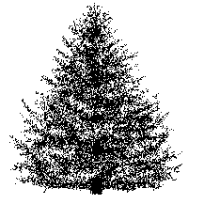

Rime: ‘aw,’ ‘ay.’

She saw the gray claws poking out of the clay.

The crab crawled

The crab crawled away into

The crab crawled away into the nearby

The crab crawled away into the nearby bay.

p-aw, paw

p-ay, pay

s-ay, say

s-aw, saw

sh-awl, shawl

c-r-awl, cr-awl, crawl

c-r-ay-fish, cray-fish, crayfish

p-l-ay, pl-ay, play

She saw the gray claws poking out of the clay.

