Name: __________________________________________
Story Map for Lucky Goes to Dog School
Title: Lucky Goes to Dog School  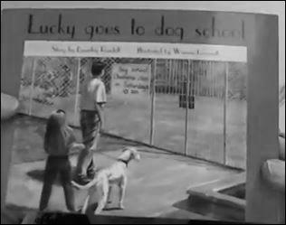 |  | Setting:
Main Character: | Problem: |  | Solution:
What Happens Next?

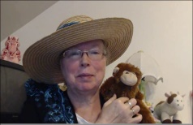http://www.topthemonkey.com

