Name: __________________________________________
Directions: In the box draw your amazing robot. Write a sentence or two about it.

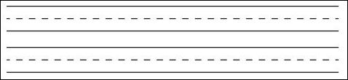
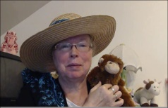http://www.topthemonkey.com

