Name: __________________________________________
Directions: If you were a bug, what would your house look like? Write a sentence or two about it.

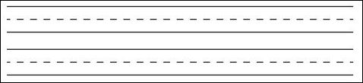
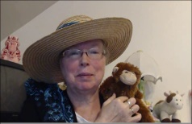http://www.topthemonkey.com

