Name: __________________________________________
Story Map for Father Bear Goes Fishing
Title: Father Bear Goes Fishing  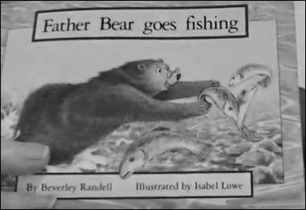 |  | Setting:
Main Character: | Problem: |  | Solution:
What Happens Next?

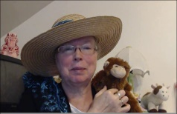http://www.topthemonkey.com

