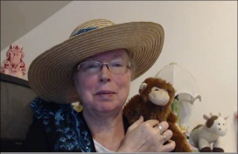 Book: Red or Blue

*(Compare/Contrast)*

Name: _____________________________

Directions: Color each picture.

|  |  |  |
| --- | --- | --- |
| RED | BOTH | BLUE |
|  |  |  |
| YELLOW | BOTH | BLACK |
|  |  |  |
| PURPLE | BOTH | ORANGE |
|  |  |  |