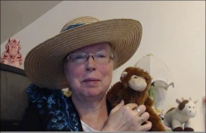 Book: Little Kittens

*(Compare/Contrast)*

Name: _____________________________

Directions: Cut and paste the three pictures in the correct box.

|  |  |  |
| --- | --- | --- |
| Kitten | BOTH | Monkey |
|  |  |  |

