Come to My House (cut-out pictures/sentences)

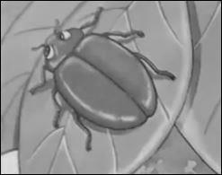 | 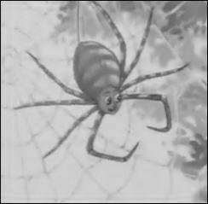
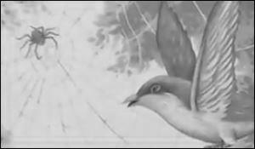 | 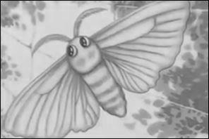

The beetle said, “No, thank you.” | The bird said, “I will come to your house.”
The spider said, “Come to my house.” | The moth said, “No, thank you.”

