Name: __________________________________________
Directions: In the box draw a picture of your favorite cap. Write a sentence or two about it.

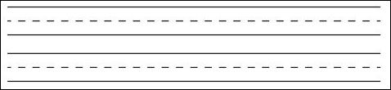
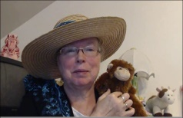http://www.topthemonkey.com

