Book 12: The Grand Raft Rand
Curriculum Extension Activities
- Using various noise making instruments from the environment, have students clang and hit a favorite tune. Next, put the instruments in order from the lowest pitch to the highest pitch, and vice-versa.
- Take a walk outside and have students listen to the various noises in the environment. Bringing a pencil and pad, have the students write down or draw the noises they hear. Upon returning to the classroom, have the students make a booklet of the various sounds, writing a simple sentence at the bottom such as, “The wind goes swoosh.”
- Have students sit still in the classroom for 3 minutes, just writing or drawing the sounds they hear. This calls attention to sounds in the environment that are often unnoticed.
Final Consonant Blend Words: band, raft, rocks, clunk, bang, clang, stick, flick, grand, land

Written by,
Dr. Janie Spaht Gill
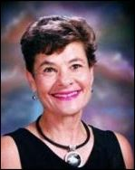
http://www.arobookpublishing.com

