Book 11: The Trash Can Band
Curriculum Extension Activities
- Have the class play a guessing game. One of the students is “it” and makes a noise with an instrument of some type. The other children, with eyes closed, guess what student used to make the noise. The student that guesses correctly becomes “it” for the next round.
- Use various materials in the room, such as pencils rapping, feet tapping, hands clapping, lips smacking, etc. to form a rhythm band. Use the make-believe instruments to accompany a favorite tune.
- Discuss places in nature that noises are heard. List other things the author could have used in the book to make a band, such as frogs croaking, birds chirping, dogs barking, cats howling, etc.
Words with initial consonant blends: trash, clock, clam, shut, slam, glass, bling, cling, trap, clap, snap, plop, slop, wham, slams, blam, what

Written by,
Dr. Janie Spaht Gill
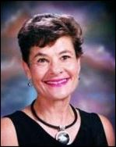
http://www.arobookpublishing.com

