Book 10: What Red Fred Did
Curriculum Extension Activities
- Have a talent contest, with the children standing and performing an activity of movement. Have the performer name an animal that can perform that movement. List the various animals in alphabetical order on board.
- Create a model habitat for one of the animals depicted in the book, or one not found in the book. The habitat and animal may be drawn and cut out of construction paper, and then glued inside a shoebox. If students are able, they may write descriptions of their habitat.
- Discuss why different animals move differently and what on their body enables them to move that way. What on a cat enables them to crawl? How does a rabbit jump? How does a snake slither? How does a bug fly?
- Measure how far the children can jump, and record this information next to their names on a chart. Then, measure their height. Compare their height to the distance they jumped.
Words with initial consonant blends: whop, stop, flump, slap, thump, big

Written by,
Dr. Janie Spaht Gill
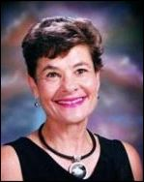
http://www.arobookpublishing.com

