Mrs. Nichols and Tops the Monkey: A Book of Rimes for Kindergarten and First Grade Students

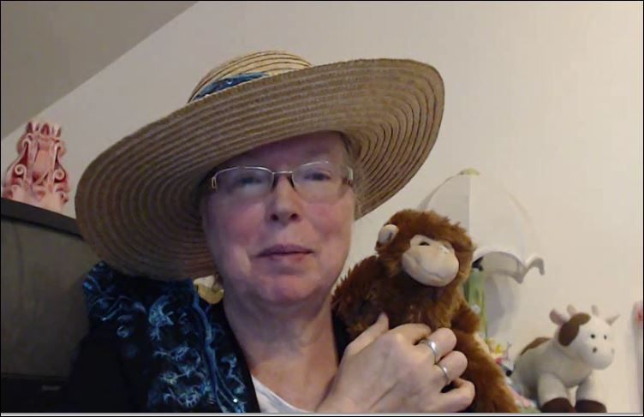

© original: TXu-1-586-072

Rime: ‘at’

The cat sat and saw a rat.

That went

That went behind

That went behind a hat.

b—a—t, b—at, bat

m—a—t, m—at, mat

f—a—t, f—at, fat

p—a—t, p—at, pat

s—p—a—t, sp—at, spat

ch—a—t, ch—at, chat

The cat sat and saw a rat.

..\..\..\..\Program Files\Microsoft Office\Clipart\Pub60Cor\AN02724_.wmf ..\..\..\..\Program Files\Microsoft Office\Clipart\standard\stddir1\AN04325_.WMF

# Rime: ‘ap’

A map fell on his lap.

He put it

He put it under

He put it under his cap.

m—a—p, m—ap, map

t—a—p, t—ap, tap

c—a—p, c—ap, cap

l—a—p, l—ap, lap

c—l—a—p, cl—ap, clap

ch—a—p, ch—ap, chap

A map fell on his lap.

..\..\..\..\Program Files\Microsoft Office\Clipart\standard\stddir2\BD07815_.WMF

# Rime: ‘an’

He ran to get a pan.

He fell

He fell over

He fell over the fan.

p—a—n, p—an, pan

f—a—n, f—an, fan

r—a—n, r—an, ran

b—r—a—n, br—an, bran

ch—a—n, ch—an, chan

He ran to get a pan.

..\..\..\..\Program Files\Microsoft Office\Clipart\standard\stddir3\HH01906_.wmf

# Rime: ‘in’

She had to win to get the pin.

Win, win, win is all

Win, win, win is all she could

Win, win, win is all she could think about.

w—i—n, w—in, win

b—i—n, b—in, bin

f—i—n, f—in, fin

p—i—n, p—in, pin

s—p—i—n, sp—in, spin

th—i—n, th—in, thin

She had to win to get the pin.

..\..\..\..\Program Files\Microsoft Office\Clipart\standard\stddir1\BD07017_.WMF

# Rime ‘ip’

The pup will sip at the well that tips.

When the well

When the well falls over

When the well falls over, the ground

When the well falls over, the ground will rip.

s—i—p, s—ip, sip

l—i—p, l—ip, lip

t—i—p, t—ip, tip

r—i—p, r—ip, rip

t—r—i—p, tr—ip, trip

sh—i—p, sh—ip, ship

The pup will sip at the well that tips.

..\..\..\..\Program Files\Microsoft Office\Clipart\standard\stddir1\AN01339_.wmf

# Rime: ‘op’

The top will spin around the mop.

It went out the

It went out the back door

It went out the back door and did

It went out the back door and did not stop.

m—o—p, m—op, mop

h—o—p, h—op, hop

p—o—p, p—op, pop

t—o—p, t—op, top

s—t—o—p, st—op, stop

sh—o—p, sh—op, shop

The top will spin around the mop.

..\..\..\..\Program Files\Microsoft Office\Clipart\standard\stddir3\IN00270_.wmf

# Rime: ‘ug’

He got a hug when he gave her the mug.

“I like it

“I like it a lot.

“I like it a lot. Thanks for

“I like it a lot. Thanks for the mug.”

m—u—g, m—ug, mug

h—u—g, h—ug, hug

b—u—g, b—ug, bug

r—u—g, r—ug, rug

s—l—u—g, sl—ug, slug

ch—u—g, ch—ug, chug

He got a hug when he gave her the mug.

..\..\..\..\Program Files\Microsoft Office\Clipart\standard\stddir3\FD01540_.wmf

Rime: ‘ack’, ‘ick’, ‘ock’, ‘uck.’

Clucky the duck went swimming in the pond.

“Quack, quack,”

“Quack, quack,” said Clucky.

“Quack, quack,” said Clucky the duck.

“Quack, quack,” said Clucky the duck swimming in the pond.

l—ock, lock

l—uck, luck

l—ick, lick

l—ack, lack

s—l—ack, sl—ack, slack

sh—ack, shack

Clucky the duck went swimming in the pond.

..\..\..\..\Program Files\Microsoft Office\Clipart\standard\stddir1\BD06318_.WMF

# Rime: ‘ash’

The rat was in the trash.

It liked

It liked to nibble

It liked to nibble on

It liked to nibble on a pickle.

c—ash, cash

m—ash, mash

h—ash, hash

r—ash, rash

c—r—ash, cr—ash, crash

t—r—ash, tr—ash, trash

The rat was in the trash.

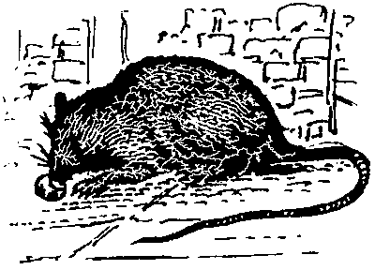

Rime: ‘ank,’ ‘ink’, ‘unk.’

Sammy the skunk did not like to stink.

“I can not

“I can not help if

“I can not help if I stink

“I can not help if I stink,” said Sammy the skunk.

p—i—n—k, p—ink, pink

s—i—n—k, s—ink, sink

s—a—n—k, s—ank, sank

s—u—n—k, s—unk, sunk

p—l—u—n—k, pl—unk, plunk

ch—u—n—k, ch—unk, chunk

Sammy the skunk did not like to stink. ..\..\..\..\Program Files\Microsoft Office\Clipart\standard\stddir1\AN04330_.WMF

# Rime: ‘est’

Billy did his best on the test.

“I hope

“I hope I got

“I hope I got an ‘A’ on

“I hope I got an ‘A’ on the test,” said Billy.

t—e—s—t, t—est, test

n—e—s—t, n—est, nest

r—e—s—t, r—est, rest

b—e—s—t, b—est, best

w—e—s—t, w—est, west

ch—e—s—t, ch—est, chest

Billy did his best on the test.

## A+

# Rime: ‘ing’

The king liked to wear his ruby ring.

“It looks

“It looks nice on

“It looks nice on me,”

“It looks nice on me,” said the king.

k—i—n—g, k—ing, king

r—i—n—g, r—ing, ring

s—i—n—g, s—ing, sing

w—i—n—g, w—ing, wing

s—w—i—n—g, sw—ing, swing

th—i—n—g, th—ing, thing

The king liked to wear his ruby ring.

..\..\..\..\Program Files\Microsoft Office\Clipart\standard\stddir2\BD07755_.WMF